ISR-ST3008
8 Channel H.264 1080P P2P DVR/NVR/HVR

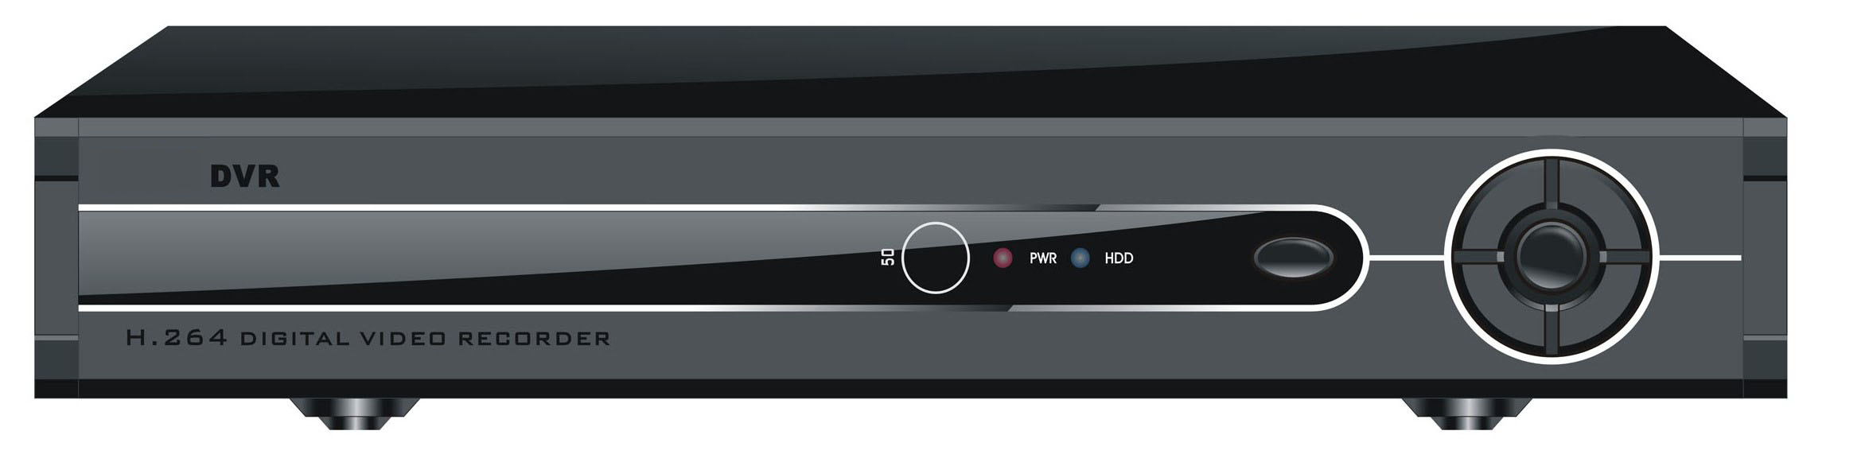

Model:
ISR-ST3008
☆ 8CH DVR/NVR/HVR Multi-mode input
☆ 8CH 960H real time recording, 2CH 960H real time playback
☆ 8CH video input, 1CH audio input, No alarm, with RS485
☆ with Network function, free DDNS, Cloud service, P2P function, Support all kinds of mobile view
☆ Support USB 3G & USB WiFi
☆ Support TV, VGA & HDMI simultaneously output, VGA&HDMI can be 1080P
☆ Support 1pcs of HDD, Max. 4TB

Features:
HD DVR Three in one: combines the functions of DVR/HVR/NVR together, multi-mode input, support 8ch 960H for encode and 1CH 960H for decode, support analog + network HD video hybrid input, support full HD network video input.
Step on the Internet: Can penetrate through all kinds of network via cloud service, to do remote control easily & conveniently without any complicated setting.
Compression algorithm ideal: Compression algorithm upgraded to H.264 Main Profile, the advanced space-time filter technique makes the code stream lowered at least 30%.
Playback quality: real-time recording synchronously (8ch 960H real-time encode), real-time multi-channel playback synchronously
Main and Sub Stream: Support main stream and extra steam encode synchronously. Main stream is for local storage to maintain the image quality, extra stream is for network real-time transmission, to easily solve the bottleneck problem of bandwidth.
Mobile monitor: Support all kinds of mobile monitor (iPhone, Windows Mobile, BlackBerry, Symbian, Android)
Display: Support TV, VGA & HDMI output synchronously, make the traditional monitor display effect upside down
Operation interface: similar WINDOWS operating style, powerful right button menu function of mouse, make it easy for using.
Network: Powerful net service(support DHCP, PPPOE, FTP, DNS, DDNS, NTP, UPNP, EMAIL, IP authority, IP search, alarm center, etc), complete enclosure(WEB, CMS, SDK), to easily achieve interconnection.
Browsers: Support multi-browser(IE, Chrome, Firefox, Safari)
Remote Access: Self enclosed with DNS function (ARSP), one-key to enable remote control, and support DNS of 3322, dyndns, oray, myq-see, etc
Device port: Device port: support 1 SATA port, 1HDD of 4T, 2 USB2.0 port for operation of mouse control, back up, burning and upgrade
Support multi languages: Chinese, English, French, Portuguese, Russian, Italian, Spanish, Thai, Greek, Japanese, German, Polish, Finnish, Turkish, Vietnamese, Hungarian, Hebrew, Persian, Romanian, Korean, Indonesian, Swedish, Arabic
Others: Completed protective circuit, unique treble watchdog function, make device never crashed; special “black-box” technology to monitor the device process, greatly reduce the maintenance cost

Specification:
 | Model | ISR-ST3008
System | Main processor | Technical grade embedded microprocessor
System | Operating system | Embedded LINUX operating system
System | System resource | Multi-channel real-time recording synchronously, multi-channel real-time playback, multi-channel multi-user network operation, USB back up.
Interface | Operation interface | 16bit real color GUI interface support mouse operation
Interface | Display screen | 1/4/8 screen (take analog channel as an example, other is base on the selected channel mode)
Video | Video standard | PAL(625 lines, 50fps); NTSC(525 lines, 60fps)
Video | Image encode | H.264(High Profile)
Video | Monitor quality | Monitor: D1; VGA, HDMI: High definition(support 1920*1080, 1280*720,1440*900,1280*1024, 1024*768, 800*600)
Video | Playback quality | 1080P/720P/D1/HD1/CIF
Video | Encode capability | 8ch 960H real-time
Video | Decode capability | 2ch 960H real-time
Video | Multi-mode video input | Local analog input:  8 *D1  Local analog + network digital input:  2 *D1+(1*1080P+1*720P)  Network digital input:  8*960H/4*720P /2*1080P/1*720P+7*D1/1*1080P+1*720P+2*D1
Video | Motion detection | Each channel can set 192(16*12)detection area; can set multi-level of flexibility (for local analog channel only)
Audio | Audio compression | G711A
Audio | Bidirectional talk | support
Record and playback | Record mode | manual>alarm>motion detection>timing
Record and playback | Local playback | 1-4ch playback synchronously (take local analog input for example, other is depended on the selected channel mode)
Record and playback | Video search | Time, date, event, channel search
Storage and back up | Space occupation | Video: CIF 4~5G/day*channel, D1 16~20G/day*channel;  Audio: 691.2M/day*channel
Storage and back up | Video storage | Local HDD, Network
Storage and back up | Back up mode | Network backup, USB portable HDD, USB imprint, SATA imprint
Interface | Video input | 8ch CVBS/BNC(1.0Vp-p,75Ω)
Interface | Video output | 1ch CVBS/BNC(1.0Vp-p,75Ω), 1ch VGA, 1ch HDMI
Interface | Loop output | optional
Interface | Audio input | 1ch RCA(200-2800mV,30KΩ)
Interface | Audio input | 1ch RCA(200-3000mV,5KΩ)
Interface | Alarm input | N/A(can extend to 4ch)
Interface | Alarm output | N/A(can extend to 1ch)
Interface | Network port | RJ45 10M/100M self-adaptive Ethernet port
Interface | PTZ control | 1 RS485, support multi kinds of PTZ protocol
Interface | USB port | 2*USB2.0
Interface | HDD port | 1 SATA ports(each max to 4T)
Interface | Wireless port | 3G, WIFI(extension via USB port)
Other | Power | 12V/3A
Other | Consumption | <15W(not including HDD)
Other | Temperature | 0°C -＋55°C
Other | Humidity | 10%－90%
Other | Atmosphere pressure | 86kpa－106kpa
Other | Dimension | L233*W300*H45 mm
Other | Weight | 1.96kg
The specification is subject to change without notice

