ISR-Kit-4103
4Ch DVR Kit
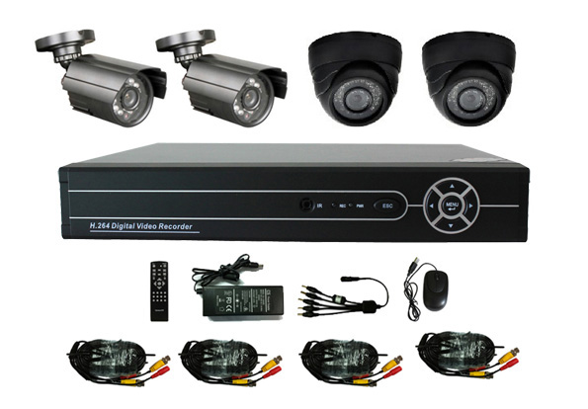

Models
ISR-Kit-4103C ISR-3004B DVR+ 2*1/4 CMOS 420TVL Waterproof camera and 2*1/4 CMOS 420TVL Dome Camera+ Accessories
ISR-Kit-4103P ISR-3004B DVR+ 2*1/4 Sharp 420TVL Waterproof Camera and + 2*1/4 Sharp 420TVL Dome Camera+ Accessories
ISR-Kit-4103S ISR-3004B DVR+ 2*1/3 SONY 420TVL Waterproof Camera and + 2*1/3 SONY 420TVL Dome Camera+ Accessories

Package:
★ 1 pcs of 4CH Stand Alone DVR (ISR-3004B)
★ 2 pcs of metal waterproof camera: 10-20M IR,3.6mm lens, with 3-axis bracket;
★ 2pcs of plastic dome camera: 10-20m IR, 3.6mm lens
★ 1 pcs of switch power adaptor
★ 4 pcs of 60 feet (around 18M) BNC/DC cable
★ 1 pcs of remote controller
★ 1 pcs of mouse
★ 1 pcs of user manual & CD
★ 1 pcs of 1-5 splitter cable

DVR Features:

☆ 4CH entry level DVR
☆ 4CH D1 real time recording
☆ 4CH video input, 1CH audio input, 1CH audio output, No alarm, No RS485
☆ Support TV, VGA simultaneously output
☆ Support 1pcs of HDD, Max. 2TB
Compression algorithm ideal: Compression algorithm upgraded to H.264 Main Profile, the advanced space-time filter technique makes the code stream lowered at least 30%.
Playback quality: real-time recording synchronously (4ch D1 real-time encode), real-time multi-channel playback synchronously (4ch D1 real-time decode)
Main and Sub Stream: Support main stream and extra steam encode synchronously. Main stream is for local storage to maintain the image quality, extra stream is for network real-time transmission, to easily solve the bottleneck problem of bandwidth.
Mobile monitor: Support all kinds of mobile monitor (iPhone, Windows Mobile, BlackBerry, Symbian, Android)
Hexaplex operation simultaneously: Preview, recording, playback, backup, network live, mobile phone view.
Operation interface: similar WINDOWS operating style, powerful right button menu function of mouse, make it easy for using.
Network: Powerful net service(support DHCP, PPPOE, FTP, DNS, DDNS, NTP, UPNP, EMAIL, IP authority, IP search, alarm center, etc), complete enclosure(WEB, CMS, SDK), to easily achieve interconnection.
Browsers: Support multi-browser (IE, Chrome, Firefox, Safari)
Remote Access: Self enclosed with DNS function (ARSP), one-key to enable remote control, and support DNS of 3322, dyndns, oray, myq-see, etc
Device port: Device port: support 1 SATA port, 1HDD of 2T, 2 USB2.0 port for operation of mouse control, back up, burning and upgrade
Support multi languages: Chinese, English, French, Portuguese, Russian, Italian, Spanish, Thai, Greek, Japanese, German, Polish, Finnish, Turkish, Vietnamese, Hungarian, Hebrew, Persian, Romanian, Korean, Indonesian, Swedish, Arabic
Others: Completed protective circuit, unique treble watchdog function, make device never crashed; special “black-box” technology to monitor the device process, greatly reduce the maintenance cost

 | DVR Model | ISR-3004B
System | Main processor | Technical grade embedded microprocessor HI 3515
System | Operating system | Embedded LINUX operating system
System | System resource | Multi-channel real-time recording synchronously, multi-channel real-time playback, multi-channel multi-user network operation, USB back up.
Interface | Operation interface | 16bit real color GUI interface support mouse operation
Interface | Display screen | 1/4 screen
Video | Video standard | PAL(625 lines, 50fps); NTSC(525 lines, 60fps)
Video | Image encode | H.264(High Profile)
Video | Monitor quality | Monitor: D1; VGA
Video | Playback quality | D1/HD1/CIF
Video | Encode capability | 4ch D1 real-time
Video | Decode capability | 4ch D1 real-time
Video | Image control | 6 options
Video | Motion detection | 396(22×18) detection areas, multiple sensitivity
Audio | Audio compression | G711A
Audio | Bidirectional talk | support
Record and playback | Record mode | manual>alarm>motion detection>timing
Record and playback | Local playback | 1-4ch playback synchronously
Record and playback | Video search | Time, date, event, channel search
Storage and back up | Space occupation | Video: CIF 4~5G/day*channel, D1 16~20G/day*channel;  Audio: 691.2M/day*channel
Storage and back up | Video storage | Local HDD, Network
Storage and back up | Back up mode | Network backup, USB portable HDD, USB imprint, SATA imprint
Interface | Video input | 4ch CVBS/BNC(1.0Vp-p,75Ω)
Interface | Video output | 1ch CVBS/BNC(1.0Vp-p,75Ω), 1ch VGA
Interface | Loop output | No
Interface | Audio input | 1ch RCA(200-2800mV,30KΩ)
Interface | Audio input | 1ch RCA(200-3000mV,5KΩ)
Interface | Alarm input | N/A
Interface | Alarm output | N/A
Interface | Network port | RJ45 10M/100M self-adaptive Ethernet port
Interface | PTZ control | N/A
Interface | USB port | 2*USB2.0
Interface | HDD port | 1 SATA ports(each max to 2048G)
Interface | Wireless port | No
Other | Power | 12V/3A
Other | Consumption | <10W(not including HDD)
Other | Temperature | 0℃-＋55℃
Other | Humidity | 10%－90%
Other | Atmosphere pressure | 86kpa－106kpa
Other | Dimension | L220*W250*H40 mm

Camera Features:

IR Color Camera
3.6mm Fixed Lens
24pcs of ø5mm IR LED
20m Night Vision
IR Auto-open by CDS Control in Low Lux

Model | Dome/Waterproof Camera for ISR-Kit-4103C | Dome/Waterproof Camera for ISR-Kit-4103P | Dome/Waterproof Camera for ISR-Kit-4103S
Color/B&W | Color
Image Sensor | 1/4’’ CMOS | 1/4’’ Sharp CCD | 1/3’’ SONY CCD
Resolution | 420TVL
Lens | 3.6mm Fixed Lens
IR LEDs | 24pcs Φ5 LED, 20m IR Distance
Sync System | Internal
Video Output | 1.0Vp-p Composite Video output at 75Ω
Power Requirement | DC12V±1V
Operation Temperature | -20°C~50°C
Gain Control | Auto
Gamma Correction | >0.45
White Balance | Auto
S/N Ratio | More than 50dB (AGC Off)
Electronic Shutter | PAL: 1/50~1/100,000 sec/ NTSC: 1/60~1/100,000 sec

